**Get R/RStudio**

We’ll be using R with RStudio in EEMB144L for managing data, performing data analysis, and for producing figures.

Why?

* Both are **freely available** and cross platform (Windows, Mac OS X, Linux)
* It’s easy to keep things organized in once place
* Your analysis is annotated, repeatable, cross-platform, and sharable
* It’s not headache inducing to make changes
* You can make beautiful figures!

What’s the difference between R and RStudio?

* R is basically a powerful calculator where all the real work happens
* RStudio gives you a much more user-friendly interface to work with R.

We love R and RStudio makes it much easier to work with. There’s a steep initial learning curve associated with learning how to use these tools, but you can get past it with trial and error and a lot of practice. Once you do, you’ll recognize the possibilities!

**One of the hardest parts in getting started is getting R/RStudio, installing them, and understanding how they work on your computer.**

The step-by-step instructions in this document are to help you get R/RStudio on your own computer, along with several tools we’ll be using. **If you have problems, get in touch with Nick!**

*\*Note: If you have older versions of R/RStudio installed, we recommend updating. To get the updated version of R, just follow the instructions below to get Version 4.0.2. To update RStudio, you can follow the instructions below OR go to the ‘Help’ tab in RStudio, click on “Check for Updates,” then choose “Quit and Download” if you’re running an older version, then follow instructions below to download the newest version. The versions we’ll use are:*

*R: Version 4.0.2 -- "Taking Off Again" (released 2020-06-22)*

*RStudio: Version 1.3.1073 (released 2020-08-11)*

**STEP 1. GET R**

You can visit <https://www.r-project.org/> to learn a little about R. You can download R from the CRAN (**C**omprehensive **R** **A**rchive **N**etwork) here: <https://cloud.r-project.org>

1. Go to the CRAN mirror at the following URL: <https://cloud.r-project.org>
2. Choose the correct “Download R for…” option from the top (Mac or Windows), then:

* For Mac users, select the appropriate version for your operating system (the latest release is version 4.0.2 “Taking Off Again”), then choose to Save or Open
* For PC users, choose “Install R for the first time” (next to the *base* subdirectory) and then “Download R 4.0.2 for Windows”

1. Once downloaded, save, open once downloaded, agree to license, and install like you would any other software. If it installs, you should be able to find the R icon in your applications:



**STEP 2. GET RSTUDIO**

Again, we won’t be using R directly. We’ll be interacting with the user-friendly interface of RStudio. That means you **must have R already installed** for RStudio to work. Make sure you’ve successfully installed R in Step 1 before getting RStudio. Then…

1. Go to <https://www.rstudio.com/products/rstudio/download/> to download RStudio Desktop (Open Source License). You’ll know you’re clicking the right one because it says “Free” right above it.
2. Click download, which takes you just down the page to where you can select the correct version under **Installers for Supported Platforms** (almost everyone will choose one of the first two options, RStudio for Windows or Mac OS X).
3. Click on the correct installer version, save, open once downloaded, agree to license and install like you would any other software.

**STEP 3. OPEN RSTUDIO AND MAKE SURE THINGS ARE WORKING**

1. Once you have R then RStudio installed, you can find and click on the RStudio icon to open. **When you open RStudio, it automatically also runs R. So even though you’ll be using both, you only need to actively open RStudio.** The RStudio icon looks like this:



1. When you open RStudio, you should get a workspace that looks something like the screen shot below. Does that show up? If yes, you have R and RStudio installed correctly, and you can move on to Step 4.

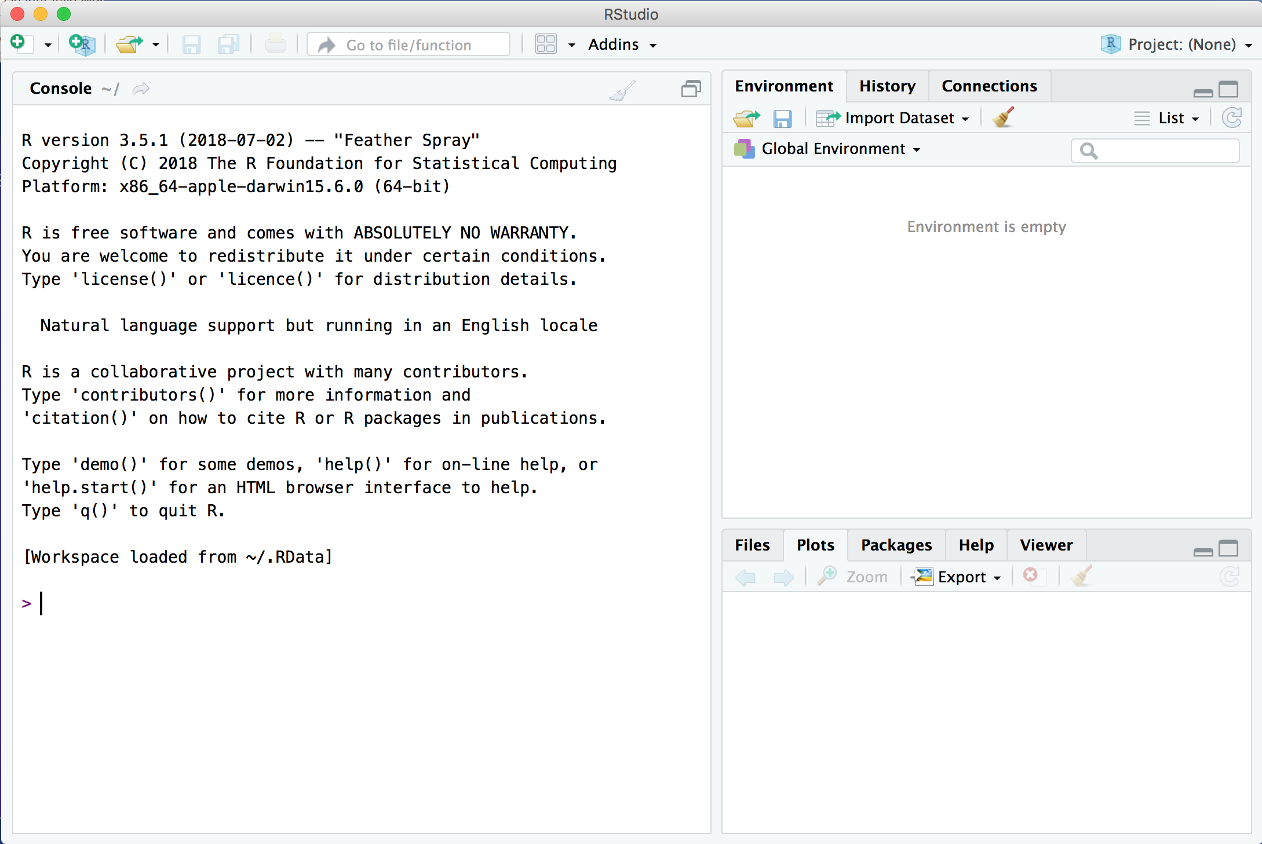

**STEP 4. INSTALL TIDYVERSE PACKAGE**

When you install R, it comes with a bunch of built-in tools that are automatically installed with it. There also exist additional tools and packages that will make your life much easier. For Lab 1, we’ll use packages that exist in the aggregate *tidyverse* package. The tidyverse contains a collection of very useful packages that play nicely together for data exploration, manipulation, wrangling and visualization. Here, you’ll install the *tidyverse* package.

1. Open RStudio
2. In the CONSOLE WINDOW of RStudio, you should see an active cursor waiting patiently for you to type something:

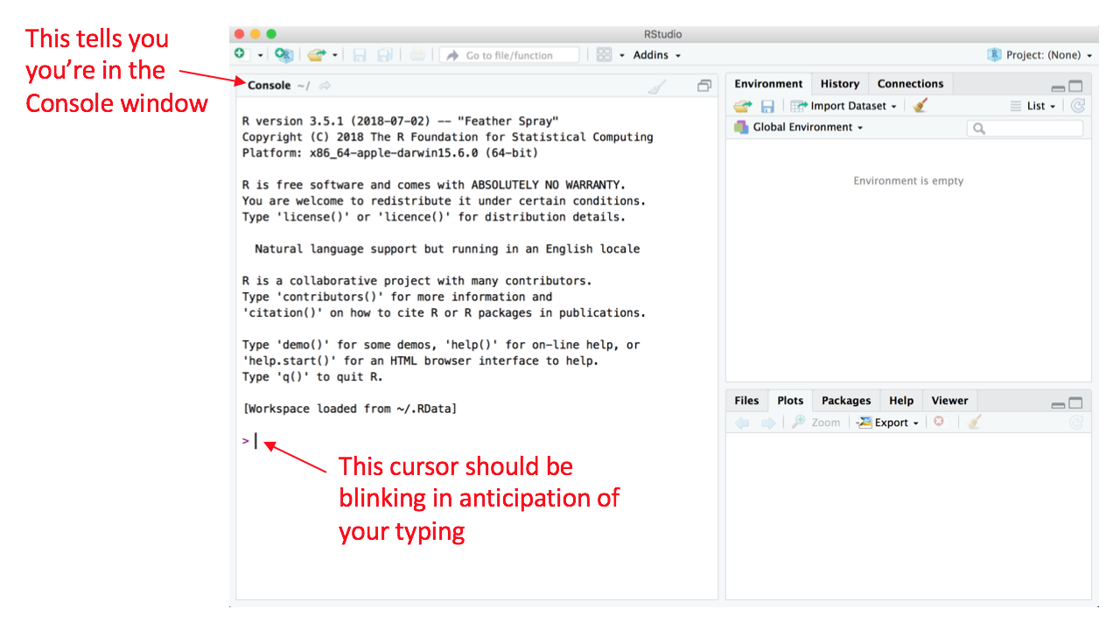

1. To install the tidyverse, type the following (exactly) where that cursor is waiting, then press ‘Enter’:

install.packages(“tidyverse”)

1. After you press ‘Enter,’ you should see a whole bunch of green text starting to appear in the Console Window. That’s good – it’s just a record of what’s being downloaded/installed. This process can go on for a few minutes (the tidyverse has a lot of different components).

You will know it’s done when you get something like this (yours will differ slightly), with no red error messages, and the active cursor shows up again waiting for your next command:

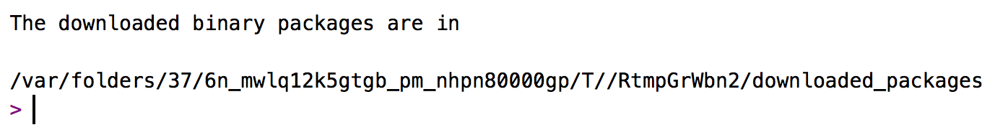

1. Once it’s installed, you can ensure that everything worked out by *loading* the tidyverse package (that just means that it’s bringing the package into R’s active brain, instead of just existing in a dormant phase). To load the tidyverse package you’ve just installed, type the following into the console where the active cursor is waiting, then press ‘Enter’:

library(tidyverse)

When you press enter, some information will come up below the command (this might also take a minute or two to load). Don’t worry too much about it – we’ll learn what it tells us in 144L. It may look like this:

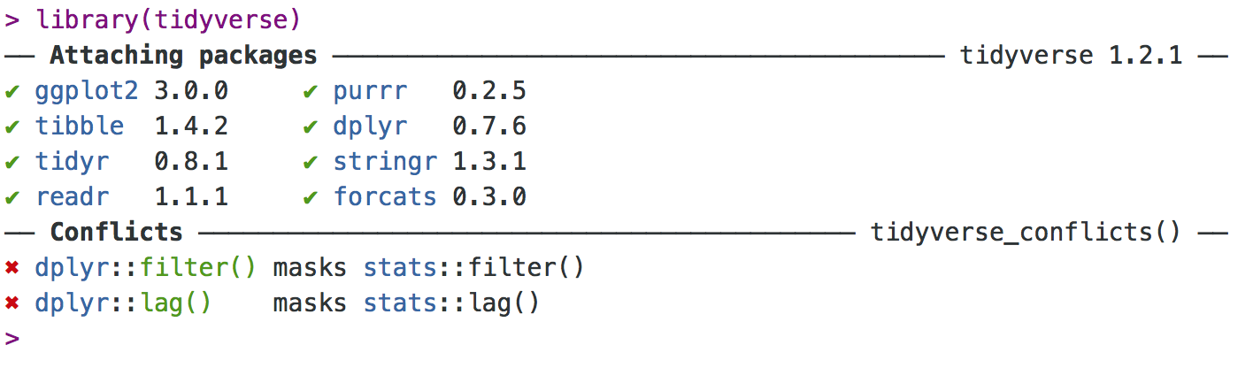

If you got something similar with no error messages (different from the ‘Conflicts’ section – that’s fine, as we’ll also learn later) then you’ve successfully installed R, RStudio, and the tidyverse package. **Congratulations!** Now you can close RStudio (you don’t need to “Save the Workspace” or anything else when prompted).

**If you CANNOT get this working, let Nick know ASAP.**